EE / CprE / SE 491 Weekly Report

March 27 - April 2

sddec24-16

Designing a Smart Plant Nurturing System Enabled by IoT Technology

Faculty Advisor / Client: Md Maruf Ahamed

**Team Members:**

* Tejal Devshetwar - Frontend
* Holden Brown - Frontend/backend
* Blake Hardy - Backend
* Cameron Jones - Backend
* Cayden Kelley - Hardware
* Chase O’Connell - Hardware

**Weekly summary:**

The progress we made this week primarily built upon what we had accomplished and focused on last week. In terms of hardware development, we determined additional tests to be done using the sensors and liquid pump system, as well as the next selection of components to integrate into the system to increase functionality. We made progress on the backend development for the mobile app and are now focusing on testing this aspect of the project to ensure usability. Additionally, we were able to document our progress thus far more thoroughly including a detailed hardware schematic through the Fritzing software.

**Past Week Accomplishments:**

* Hardware System Documentation - Cayden
  + Developed a detailed diagram including the microcontroller, relays, DC-DC converter, NPK sensor, RS485 to I2C converter, soil moisture sensor, as well as their interconnections.

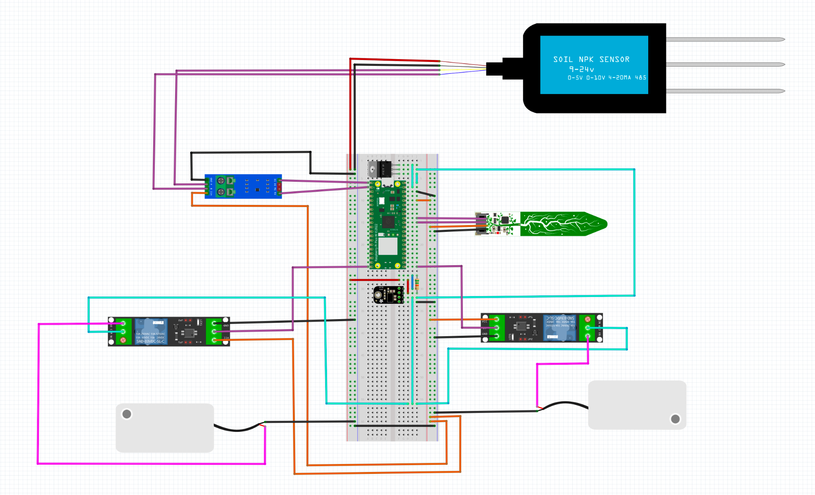

* Hardware Test Cases - Cayden, Chase
  + Determined the next steps for hardware functionality testing:
    - RS485 to I2C converter already in possession with a 3.3V input.
    - New RS485 to I2C converter functionality testing.
    - Developing test code for the Pi Pico to verify NPK sensor data.
    - Developing a framework for testing actuator and sensor data simultaneously.
* Backend Software - Blake, Cameron, Holden
  + Continued progress with REST API.
  + Focused on further developments with the Python request library.

**Plans for Coming Week + Action Items:**

* Holden Brown - I plan to setup the database and connect the app to that database. I am also going to look into using MongoDB.
* Tejal Devshetwar - Start working on the page that opens after clicking each plant card and the create account screen.
* Blake Hardy - finish pi REST api and ask somebody who remembers how to use postman for help testing it, will need to get pi to test on hardware and then test that with server once its up and running.
* Cameron Jones - begin testing the backend code with python request library data coming from the raspberry pi
* Cayden Kelley - Build documented test cases for the sensors we have chosen. Work with Chase to set up test code on the Raspberry Pi Pico to test the sensors and pumps we have on hand.
* Chase O’Connell - Continue testing hardware peripherals including the NPK sensor. Test the water dispersal devices. Set up test code on the Raspberry Pi Pico.

**Pending Issues:**

* Tejal Devshetwar
  + No issues
* Holden Brown
  + No issues
* Blake Hardy
  + No issues
* Cameron Jones
  + No issues
* Cayden Kelley
  + No issues
* Chase O’Connell
  + No issues

**Individual Contributions:**

| Team Member | Contribution | Weekly Hours | Total Hours |
| --- | --- | --- | --- |
| Tejal Devshetwar | Did not get much time to work on anything. | 1 | 24 |
| Holden Brown | Worked on the lightning talk and design document. | 2 | 30.3 |
| Blake Hardy | Worked on rest api on pi to send and receive data, using flask, going a bit slow as I get used to python’s weirdness again. | 2 | 21 |
| Cameron Jones | Began refreshing my knowledge on git lab uploaded moisture sensor code onto git. Spent more time researching Request library | 2 | 22 |
| Cayden Kelley | Developed documentation outlining options to alter power supply voltages to the necessary levels, developed an in-depth schematic of the overall hardware layout, began experimenting with the pico w and learning how to run code on it, brainstormed test cases for the NPK sensor, and developed plans with Chase for the coming week to test the hardware we have on hand. | 8 | 32.5 |
| Chase O’Connell | Determined the next set of hardware to order for further device testing. Developed plans for testing goals in the upcoming week. | 2 | 21 |